LIBRARY MANAGEMENT SYSTEM

SCHOOL OF ENGINEERING
DEPARTMENT OF COMPUTER SCIENCE AND ENGINEERING

CERTIFICATE

This is to certify that the Corner stone project work entitled “Library Management System” is submitted by

B. CHAITANYA SATYA KISHORE (24B11CS027)
K. VENKATESH (24B11CS191)
K. RUPESH (24B11CS210)
D. JASHUVA KUMAR NAIDU (24B11CS105)

In partial fulfillment of the requirements for the award of the B.Tech .degree in Information Technology for the academic year 2025-2026.

ProjectGuide Headof Department
Mr.B. Sai Ganesh, Dr.T. Sudha Rani
Assistant Professor, Assistant Professor,
Departmentof CSE DepartmentofCSE

DECLARATION

We hereby declare that the Cornerstone project entitled “Library Management System” is original and is submitted to ADITYA UNIVERSITY, Surampalem, in partial fulfillment of the requirements for the award of the B.Tech. degree in Computer Science and Engineering. We further declare that this project work has not been submitted, either in full or in part, for the award of any degree in this or any other institution. We also confirm that this work complies with the Institutional Academic Integrity and AI Usage Policy

PLACE: Surampalem
DATE: 06-04-2026
By

B. CHAITANYA(24B11CS027)
K. VENKATESH(24B11CS191)
K. RUPESH (24B11CS210)
D. JASHUVA(24B11CS105)

ACKNOWLEDGEMENT

It is with immense pleasure that we express our sincere gratitude to our Cornerstone Project Guide, Mr. B. Sai Ganesh, Assistant Professor, who has guided us throughout the project. Her valuable support, encouragement, and guidance have greatly contributed to the successful completion of this work.
We would like to thank our Deputy Heads of the Department, Dr. K. Chandra Shekar, Assistant Professor, and Dr. Hari Jyothula, Assistant Professor, Department of CSE, for their support and valuable suggestions.
Our deepest thanks to our Head of the Department, Dr. T. Sudha Rani, for her inspiration and for providing all the necessary facilities and resources required for this project.
We also extend our sincere thanks to Dr. M. V. Rajesh, Associate Dean, School of Engineering, for his encouragement and support during the course of our project.
We would like to express our sincere gratitude to Dr. G. Suresh, Registrar; Dr. A. Ramesh, Pro Vice-Chancellor (Engineering & Sciences); Dr. S. Rama Sree, Pro Vice-Chancellor (Academics); Dr. M. B. Srinivas, Vice-Chancellor; and Dr. M. Sreenivasa Reddy, Deputy Pro Chancellor and Management, Aditya University, for providing excellent infrastructure and state-of-the-art laboratories.
Finally, we would like to thank the faculty members, lab technicians, non-teaching staff, and our friends who have directly or indirectly supported us in completing this Cornerstone project successfully.

INDEX

S. No Title Page No
------------------------------------------------------------
1 ABSTRACT i
2 LIST OF FIGURES ii
3 LIST OF TABLES iii
4 ACRONYMS iv

5 1. INTRODUCTION 1
1.1 Brief Information about the Project 1
1.2 Motivation and Contribution 2
1.3 Objectives of the Project 3
1.4 Scope of the Project 4

6 2. SYSTEM ANALYSIS 5
2.1 Functional Requirements 5
2.2 Non-Functional Requirements 6
2.3 Software Requirements 7
2.4 Hardware Requirements 8

7 3. TECHNOLOGY REQUIREMENTS 9
3.1 Java 9
3.2 Swing 10
3.3 JDBC 11
3.4 MySQL / SQLite 12

8 4. DATABASE DESIGN 13
4.1 Database Overview 13
4.2 Tables Used 14
4.3 Table Structure 15
4.4 Relationships 16

9 5. SYSTEM DESIGN 17
5.1 Presentation Layer 17
5.2 Application Layer 18
5.3 Admin Module 19
5.4 Database Layer 20

10 6. SYSTEM DESIGN (MODULES) 21
6.1 User Authentication Module 21
6.2 Book Management Module 22
6.3 Search Module 23
6.4 Display Module 24
6.5 Admin Panel Module 25
6.6 Database Module 26

11 7. SYSTEM IMPLEMENTATION 27

12 8. CONCLUSION 29

13 9. FUTURE ENHANCEMENTS 30

14 10. REFERENCES 31

15 11. APPENDIX 32

ABSTRACT

The Library Management System (LMS) is a desktop-based application developed to manage library operations efficiently in an organized and digital manner. The system enables users to perform various operations such as adding, updating, deleting, searching, and viewing book records. It maintains important details like Book ID, title, author, category, and number of copies in a structured database.
The application is developed using Core Java for programming, Swing for designing the graphical user interface, and JDBC for database connectivity. A relational database such as MySQL or SQLite is used for storing and managing data. The system reduces manual effort, minimizes errors, and ensures quick access to information.
With a user-friendly interface and efficient data handling, the Library Management System improves accuracy, security, and accessibility of library records. It serves as a reliable solution for managing library activities in educational institutions and organizations.
The system helps in reducing manual errors, improving data accuracy, and providing quick access to information. It is suitable for schools, colleges, and organizations to manage library data effectively.

 | LIST OF FIGURES
Figure no. | Figure Title | Pageno.
1 | Login Screen of Library Management System | 18
2 | Dashboard for Library Management System | 18
Adding books Screen of Library Management 19
3
System
19
Updating staff details of Library Management
4
System
20
Books Information Screen of Library
5
ManagementSystem

Books Deletion Screen of Library Management 20
6
System

7 Staff Deletion Srceen of Library Management System 21

8 Updating Admin details of Library Management System 21
 | LIST OF TABLES
Table no. | Table T itle | Pageno.
1 | Admin Relational Database Table | 16
2  3 | Books Relational Database Table  Staff Relational Database Table | 16  16

ACRONYMS

LMS : Library Management System
GUI : Graphical User Interface
JDBC : Java Database Connectivity
SQL : Structured Query Language
DBMS : Database Management System
RDBMS : Relational Database Management System
JDK : Java Development Kit
IDE : Integrated Development Environment
API : Application Programming Interface
UI : User Interface

1.INTRODUCTION

  - Brief Information about the Project:

The Library Management System is a desktop-based application designed to simplify and automate the process of managing library records. This application allows users to store, retrieve, update, and manage book details efficiently through a digital platform.
The system is developed using Java and follows a user-friendly design to ensure ease of use. It provides a digital solution to traditional manual library systems, making the process faster and more reliable. The application includes essential features such as adding new books, updating records, searching books, and displaying available books.
This project mainly focuses on improving the overall efficiency of managing library data and reducing manual effort in maintaining records.
.

  - Motivation and Contribution of the Project:

n many schools, colleges, and small libraries, records are still maintained manually using registers or basic tools. This leads to several issues such as difficulty in searching books, data duplication, errors in record keeping, and time-consuming processes.
The motivation behind this project is to overcome these limitations by introducing a digital library management system. The proposed system reduces manual work and provides an organized way of handling library records.
The main contribution of this project is the development of a simple and effective application that enables easy management of books, improves data accuracy, and allows quick searching and updating of records. It also helps administrators manage library operations more efficiently.

  - Objectives of the Project:

The main objective of this Library Management System is to develop a simple, user-friendly, and efficient application that makes managing library records easier and faster.
• To provide a secure login system for users and administrators
• To store and manage book details such as Book_ID, Title, Author, Category, and Copies
• To implement functionality for adding, updating, and deleting book records
• To enable quick search of books using Book_ID or Author name
• To display all book records in a clear and organized format
• To develop an admin module to manage books and system operations
• To ensure secure storage of data using a relational database

  - Scope of the Project:

The scope of this project includes the development of a desktop-based library management system that can be used in schools, colleges, and small organizations.
The system is designed for two types of users:
• Users/Students – They can search and view book details easily
• Admin – The administrator can add, update, delete, and manage book records
This project demonstrates how a software application can be used to automate library operations and improve efficiency. It can also be extended in the future by adding features such as online book issuing/return, fine calculation, and web-based or mobile application support.

SYSTEM ANALYSIS

2.1 Functional Requirements:

The functional requirements define the core functionalities of the Library Management System. The system should perform the following operations:
• User Login
The system should allow authorized users (admin) to securely log in.
• Add Book Details
The system should allow the admin to add new books with details such as Book_ID, Title, Author, Category, and Copies.
• Update Book Records
The system should allow modification of existing book details whenever required.
• Delete Book Information
The system should allow the admin to delete book records with proper confirmation.
• Search Books
The system should allow users to search books using Book_ID or Author name.
• Display Books
The system should display all available books in a structured and organized format.
• Admin Management
The system should allow the admin to manage and control all library operations efficiently.

2.2 Non-Functional Requirements:

The system should respond quickly while performing operations such as search, add, update, and delete.
• Security
The system should provide secure login and protect data from unauthorized access.
• Usability
The system should be simple, user-friendly, and easy to operate.
• Reliability
The system should work consistently without failures and handle errors properly.
• Scalability
The system should handle increasing data and users without affecting performance.
2.3 Software Requirements:

• Operating System: Windows 10/11
• Programming Language: Java
• Frontend (GUI): Java Swing
• Database: MySQL / SQLite
• IDE: Apache NetBeans
• Connectivity: JDBC

2.4 Hardware Requirements:

• RAM: 4 GB minimum
• Hard Disk: 20 GB free space
• Input Devices: Keyboard and Mouse
• Display: Standard Monitor

TECHNOLOGY REQUIREMENTS

3.1 Java (Programming Language):
Java is a high-level, object-oriented programming language widely used for developing desktop, web, and enterprise applications. It is platform-independent, meaning programs can run on any system with a Java Virtual Machine (JVM).
In this project, Java is used to develop the core functionality of the Library Management System. It handles operations such as adding, updating, deleting, and searching book records. Java provides features like object-oriented programming, exception handling, and memory management, which help in building a reliable and efficient application.

3.2 Swing (Frontend GUI):
Swing is a part of Java used for creating graphical user interfaces (GUI). It provides components like buttons, labels, text fields, tables, and frames to design interactive applications.
In this project, Swing is used to design the frontend of the Library Management System. It helps in creating user-friendly interfaces such as login window, dashboard, add book form, search window, and display records screen. Swing improves user experience by providing a visually interactive and easy-to-use interface.

3.3 JDBC (Database Connectivity):
JDBC (Java Database Connectivity) is an API that allows Java applications to connect and interact with databases. It enables execution of SQL queries such as INSERT, UPDATE, DELETE, and SELECT.
In this project, JDBC is used to connect the Java application with the database. It handles operations like establishing database connection, executing queries, retrieving data, and closing connections. JDBC ensures smooth communication between the application and the database.

3.4 MySQL / SQLite (Database):
MySQL and SQLite are relational database management systems used to store and manage structured data efficiently.
In this project, the database is used to store book details, admin information, and other related records. It ensures data integrity, reduces redundancy, and allows quick retrieval of information. The use of a relational database helps in maintaining structured and organized data for the Library Management System.

DATA BASE DESIGN

4.1 Database Overview:
In this project, a relational database such as MySQL or SQLite is used to store and manage library data efficiently. The database stores information related to books, admin, and staff details. It ensures structured data storage, easy retrieval, and data consistency, making it suitable for managing library operations.

4.2 Tables Used:
The database consists of the following main tables:
• Admin Table – Stores admin login details such as username and password
• Books Table – Stores information about available books in the library
• Staff Table – Stores staff details and manages their association with books

4.3 Table Structure:
Each table in the database contains structured fields as follows:

Admin Table:
• Admin_ID
• Username
• Password

Books Table:
• Book_ID
• Title
• Author
• Category
• Copies

Staff Table:
• Staff_ID
• Staff_Name
• Contact
• Book_ID (Foreign Key)

4.4 Relationships:
• Each book can be associated with a staff member
• One staff member can manage multiple books
• This represents a one-to-many relationship

SYSTEM DESIGN

5.1 Presentation Layer (User Interface):

The presentation layer consists of various screens such as Login, Dashboard, Add Book, Search Book, and Display Books. These interfaces are designed using Java Swing components like buttons, labels, text fields, and tables.
This layer is responsible for interacting with the user and capturing inputs such as book details, search queries, and login credentials. It displays the processed data in a clear and organized manner. The user interface is designed to be simple, interactive, and user-friendly.

5.2 Application Layer (Business Logic):

The application layer handles the core logic of the Library Management System. It processes user inputs and performs operations such as adding new books, updating records, deleting books, and searching for specific data.
This layer acts as a bridge between the user interface and the database. It ensures that all operations are performed correctly and efficiently based on user requests. It also handles validations and controls the flow of data within the system.

5.3 Admin Module:

The system includes an admin module that provides full control over the library operations. The admin can add, update, and delete book records, as well as manage overall system functionality.
This module ensures that the data in the system remains accurate and up to date. It also helps in efficient management of library records and reduces manual effort.

5.4 Database Layer:

The database layer is responsible for storing and managing all the data related to the system. A relational database such as MySQL or SQLite is used to store information like book details, admin data, and staff records.
This layer is connected to the application using JDBC. All operations such as inserting, updating, deleting, and retrieving data are performed through SQL queries. The database ensures data consistency, integrity, and efficient storage.

SYSTEM DESIGN

6.1 User Authentication Module:
The User Authentication Module is responsible for managing secure access to the system. It ensures that only authorized users (admin) can access and perform operations in the system.
This module includes:
- Admin Login functionality
- Username and password validation
- Session handling for secure access
- Logout option
This module helps in maintaining data security by validating user credentials and restricting unauthorized access.

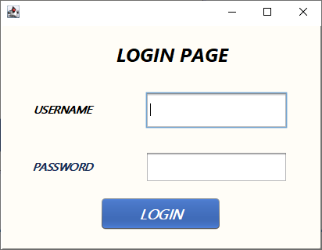

6.2 Book Management Module:
The Book Management Module is designed to manage all book-related operations in the system.
The key features of this module include:
- Adding new book details (Book_ID, Title, Author, Category, Copies)
- Updating existing book records
- Deleting book records
- Displaying all books in a structured format
This module helps in organizing and maintaining library data efficiently.

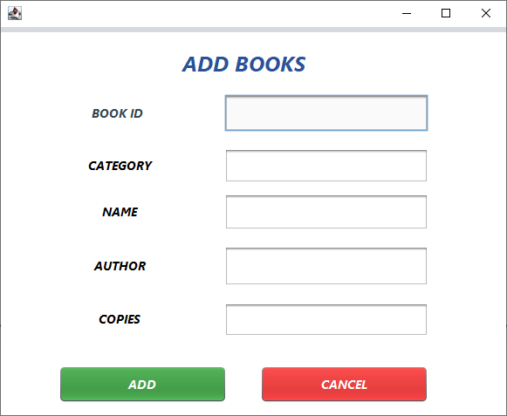

6.3 Search Module:
The Search Module allows users to quickly find books available in the library.
It provides the following functionalities:
- Search books using Book_ID
- Search books using Author name
- Display search results instantly
This module improves efficiency by enabling quick retrieval of required book information.
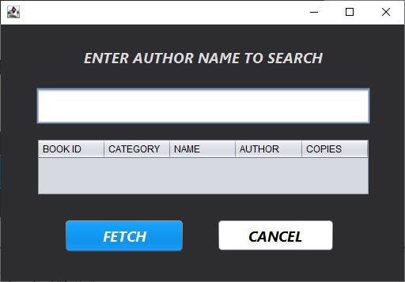

6.4 Display Module:
The Display Module is used to show all available books in the system.
It includes:
- Displaying book records in tabular format
- Showing details such as Book_ID, Title, Author, Category, and Copies
- Refreshing data dynamically after operations
This module ensures that users can view all records clearly and easily.

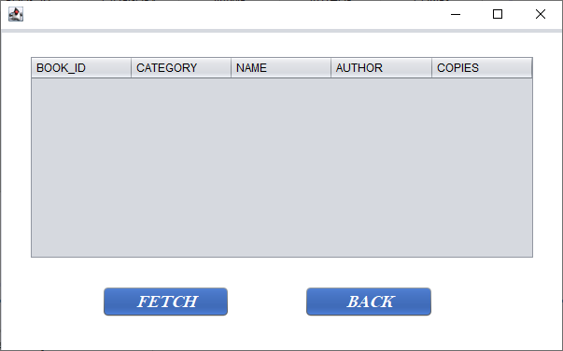

6.5 Admin Panel Module:
The Admin Panel Module provides complete control over the Library Management System.
It allows the admin to:
- Add new books
- Update book details
- Delete book records
- Manage overall system operations
This module helps in maintaining and updating the system efficiently without affecting user operations.

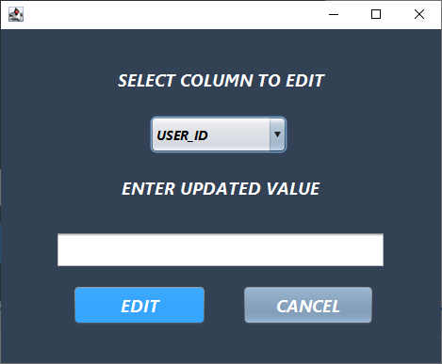

6.6 Database Module:
The database is designed to store all library-related data in structured tables.
• Admin Table
Contains admin login details such as username and password
• Books Table
Stores book details such as Book_ID, Title, Author, Category, and Copies
• Staff Table
Stores staff details and their association with books

CONCLUSION

• The Library Management System developed as part of this project successfully demonstrates the implementation of a desktop-based application using Java, Swing, JDBC, and a relational database such as MySQL/SQLite. The project effectively integrates the user interface, application logic, and database to create a complete and functional system for managing library records.
• By dividing the system into modules such as User Authentication, Book Management, Search, Display, and Admin Panel, the application follows a well-structured and modular design approach. This separation ensures better maintainability, scalability, and clarity in system development.
• The database is used to store book details, admin information, and other related data in a structured and efficient manner. JDBC is used to handle database connectivity and perform operations such as inserting, updating, deleting, and retrieving records. The Java Swing-based interface provides a smooth, interactive, and user-friendly experience.
• The system reduces manual work in libraries by automating record management, improving data accuracy, and enabling quick access to information. It enhances efficiency and provides a reliable solution for both administrators and users in managing library operations.

FUTURE ENHANCEMENTS

- The application can be further improved with the following enhancements:
- • Book Issue and Return System
Add functionality for issuing and returning books with due dates.
- • Fine Calculation System
Implement automatic fine calculation for late returns.
- • Barcode / QR Code Integration
Use barcode or QR code scanning for quick book identification and management.
- • Web-Based Application
Convert the desktop application into a web-based system for remote access.
- • Mobile Application Development
Develop an Android/iOS app for better accessibility and usability.
- • Advanced Search System
Enable filtering books by category, author, or availability status.
- • Security Improvements
Implement stronger authentication and data protection techniques.
.

REFERENCES
• Java Documentation (Oracle)
• JDBC Tutorial – GeeksforGeeks
• Java Swing Tutorial – TutorialsPoint
• Database System Concepts – Korth, Silberschatz, Sudarshan
• Programming with Java – E. Balagurusamy
• Online Tutorials and Technical Blogs

In the appendix, we provide additional information such as sample code and execution steps for running the project.

1. Application Execution
• Step 1: Compile the Java files
Command:
javac *.java
• Step 2: Run the application
Command:
java MainClassName
• Description:
This runs the Library Management System application and displays the user interface.

2. Database Connectivity (JDBC)
• Ensure database (MySQL/SQLite) is installed and running
• Configure database connection in code:
Connection con = DriverManager.getConnection(
"jdbc:mysql://localhost:3306/library","root","password");
• Description:
This connects the Java application to the database and allows data operations.

3. Sample Operations
• Add Book
• Update Book
• Delete Book
• Search Book
These operations are performed through the GUI and reflected in the database.

